**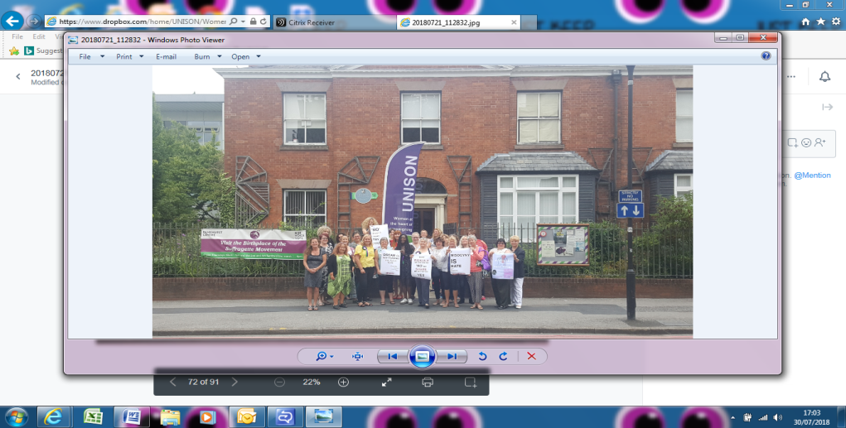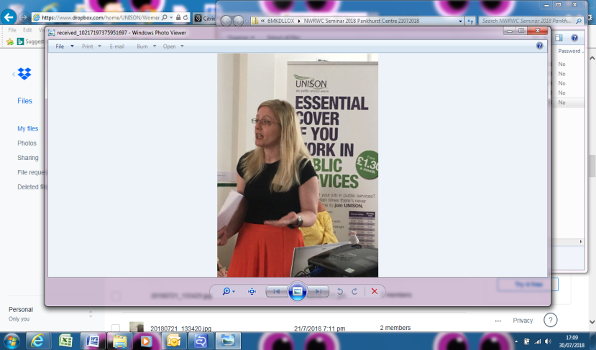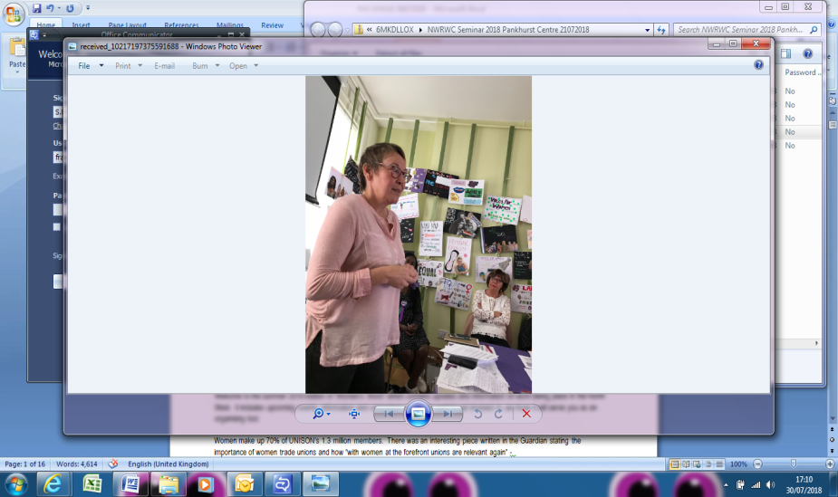**

**Words from the Chairs**

Welcome to the Autumn 2018 edition of “Women’s Words & Deeds” which contains updates and information on work taking place in the North West. It includes upcoming events, information and campaigns you might want to get involved in, we hope it will serve you as an organising tool. It is important to keep in mind that women make up 70% of UNISON’s 1.3 million members. There was an interesting piece written in the Guardian stating the importance of women trade unions and how “with women at the forefront unions are making them relevant again” - <https://www.theguardian.com/commentisfree/2017/feb/22/women-trade-unions-gender-pay-gap-discrimination>. Women continue to be strong successful campaigners – there are a huge number of campaigns that we are involved in, there is hope and we know that by taking action women can be the change!

We write following the North West Women’s seminar on 21st July. The day took place at the Pankhurst Centre, Manchester - which was an appropriate venue on the 100th anniversary of the first women’s votes. We covered issues including sexual harassment, domestic violence, misogyny as a hate crime and illegal abortions. We welcomed Audrey White, the woman who first fought back against sexual harassment in 1983 and won; Gail from Manchester Women’s Aid who told us about the sterling work they are undertaking in the community to support women beyond domestic violence; and Dr Gemma Wibberley, a researcher from UCLAN, who spoke with us about the project they are undertaking on Domestic Violence and the Trade Union Response. During the day we also had a tour of the Pankhurst House where the Suffragettes first met. We also watched a short film sourced from the TUC on illegal abortions and the trauma that women who had no choice but to go through back street illegal abortions or been sent away to have their babies physically removed from them.

See you at the next meeting, best wishes

Angie Greenhalgh & Liz Cameron

Co Chairs of our North West Regional Women’s Committee

**Deeds from our North West Women’s Representatives**

**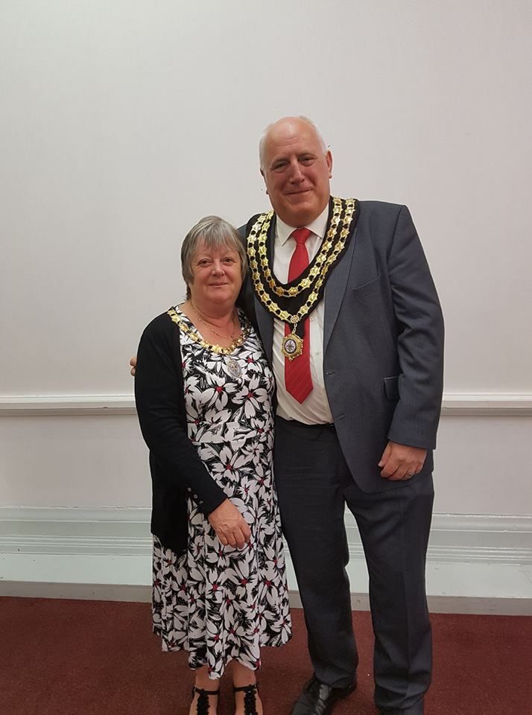**

**UNISON Health & Safety Rep to Deputy Mayor**

Sharon Webster, UNISON Cumbria County Council Branch is an active member of the UNISON North West Women’s Committee. She started her journey as a Health and Safety as she has a keen interest in keeping people safe. Sharon became involved with the WASPI women in Barrow-in–Furness after she found herself as being in a position which meant she cannot retire until she is 66 years old.

About 6 years ago Sharon joined her local Labour CLP and has canvassed at both General and Local elections after being encouraged to go and knock on doors. She said “I listened to what other canvassers were saying and followed them. It wasn’t long before I was confident to go on my own.”

Sharon is now the Deputy Mayor of Ulverston after being put forward by the Labour group. “By joining UNISON I have gained confidence which has helped me to where I am today. I am on many committees and groups and I always put forward women’s issues and support causes that have put women’s issues to the forefront.”

– next year Sharon hopes to become the Mayor of Ulverston.

**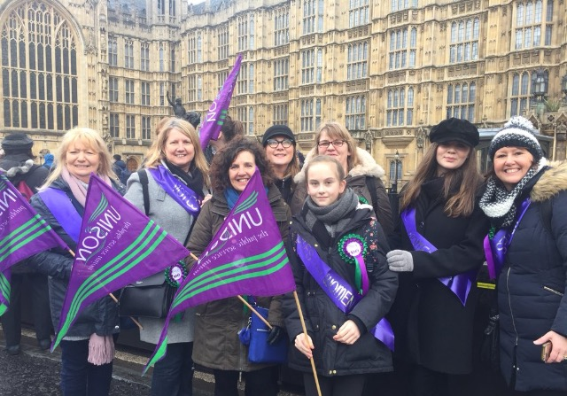March4Women**

Ann Rimmer is the Women's Officer at Liverpool and Hope Universities Branch. She along with other UNISON members attended the National Women's Conference in Liverpool.

Ann said, “We were so inspired by the speech from Helen Pankhurst and her request for UNISON women to attend the forthcoming March4Women in London and celebrating 100 years since women (some women) won the right to vote that myself and Glenys spoke to our branch and they agreed to fund a group of members to attend the event.”

She continued “The march was an amazing event and we were so glad we attended – we also had some young women attending with us who enjoyed it so much they are keen to attend next year!”

About this brief

We hope that this briefing will become a regular item for you, it will be sent to Branch Women’s and Equality Officers and contains dates for your diary, campaigns you may be interested in, dates of forthcoming events which you can advertise to your members, items you may wish to add to the agenda of your next branch committee and useful resources and links.

How to use this briefing as an organising tool

We have split the briefing into four convenient sections: **Dates for your Diary**, **Campaigns**, **On the Agenda** and **Useful Resource**. All you need to do is copy and paste it into an email or your next branch newsletter.

|  |  |  |  |
| --- | --- | --- | --- |
| **Page No** | **Section** | **Section Name** | **How to use the section as an organising tool** |
| 4 | Dates for Diary.jpg | Dates for your diary | Forthcoming events and meetings for your diary. Share these so your branch and members know what’s happening locally and nationally. |
| 6 | **Campaigns.jpgCampaigns** | Campaigns | The Campaigns section has current issues you may want to get involved in or tell your members about. |
| 13 | logo_ontheagenda.png | On the Agenda | On the Agenda are items you may wish to discuss with your branch officers or may seek a discussion and agreement from your branch at a branch committee. |
| 14 | Useful Resources.jpg | Useful Resources | Resources all of which can be shared with your members directly or via your branch communications officer. Includes useful order numbers for leaflets and website links. You may wish to add these resources to your branch newsletter or branch website. |

**Something to Share? Want to get involved?**

If you have anything coming up or any good practice you may wish to share or see included in this briefing please email them to the Chairs of the Committee at [northwest.women@unison.co.uk](mailto:northwest.women@unison.co.uk) OR If you want to get involved in any of our campaigns or the committee we would more than welcome you just email us if you need any more information [northwest.women@unison.co.uk](mailto:northwest.women@unison.co.uk)

**Represent! Voices 100 Years on**

When Saturday 2 June 2018 to Sunday 4 February 2019

Where People’s History Museum, Manchester

What People’s History Museum (PHM) in Manchester is the home of ideas worth fighting for – where our radical past can inspire and motivate people to take action – to shape a future where ideas of democracy, equality, justice and co-operation are thriving. 2018 is the 100th anniversary of the Representation of the People Act, in which all men and some women won the right to vote.  This monumental anniversary will be marked across the country, and PHM will be a leading voice in championing the heritage of the people that fought for this fundamental right.  We will programme a [year long season](http://www.phm.org.uk/news/represent-voices-100-years-on/) of exhibitions, events and learning programmes co-curated with marginalised and underrepresented communities on the theme of the struggle for representation. The project has been made possible through Heritage Lottery Funding.

**Whilst at the Museum check out Sylvia – UNISON’s Manchester Bee – send us your photos with Sylvia!**

**North West Women’s Committee**

Where UNISON North West, Arena Point, 1 Hunts Bank, Manchester, M3 1UN

What A meeting of women from across all North West UNISON branches and service groups. Women come together as a self organised group to represent members’ views, discuss matters that are important to women members, plan events and activities and share good practice of engaging, encouraging, empowering, inspiring, recruiting and maintaining women in UNISON membership. Any woman who is part of a North West branch is more than welcome to attend any North West Women’s Committee Meetings as a visitor.

If your branch does not currently have a representative you may be able to become part of the women’s committee. Anyone wishing to attend can get more information by emailing [sarah.france@unison.co.uk](mailto:sarah.france@unison.co.uk) and should in the first instance speak to their branch in order to agree for any out of pocket expenses to be paid. Members of the committee have expenses paid by the committee.

|  |  |  |  |
| --- | --- | --- | --- |
| Meeting | Date | Time | Venue |
| AGM & Motions for 2019 Conference | 16th October 2018 | 11am-3.30pm | AP |
| Women’s Committee | 15th January 2019 | 11am | AP |
| Women’s Committee | 14th May 2019 | 11am | AP |
| NW Women’s Conference 2019 | 20th July 2019 | 10am-4pm | AP (Booked) |

[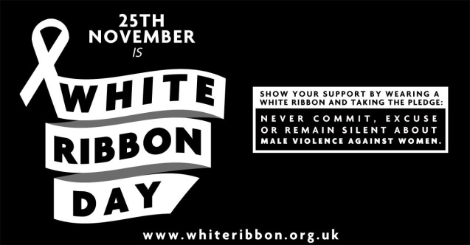](https://www.google.co.uk/url?sa=i&rct=j&q=&esrc=s&source=images&cd=&cad=rja&uact=8&ved=2ahUKEwiF5eyi-sjcAhVGaBoKHcMjBhMQjRx6BAgBEAU&url=https://www.thunderclap.it/projects/63609-white-ribbon-day-2017&psig=AOvVaw1i9c509MSd1Whtunr1A-7L&ust=1533113281496403) **White Ribbon Day**

When 25th November 2018

What Every year on White Ribbon Day 25th November (and for the following 10 days) trade unionists in workplaces across the UK show solidarity and support to women experiencing violence, sexual harassment or bullying. Thousands of people wear the white ribbon, take part in workplace based educational events and pledge not to commit, condone or remain silent about the issue. In 2017 a pack was targeted at trade union branch officers and workplace reps. it contains everything needed to mobilise around the issue before, on and after White Ribbon Day 2017. The pack includes A4 and A3 photo-copiable campaign posters with some key facts and information for union and work notice boards (electronic copies available on request) Campaigning ideas and activities handbook, Sample campaigning materials – postcards, leaflets and white ribbon badges and White Ribbon Campaign order form and links. The cost of each pack is £2.50 plus p&p. They are also happy to prepare information/draft copy and images for your union’s autumn magazines and newsletters. For more information <https://www.whiteribbon.org.uk/what-we-do>

**National Women’s Conference 2019**

When February 2019

Venue Bournemouth International Centre

What A meeting of women from across the UK from all UNISON branches and service groups. Women come together debate and agree motions which form policy and work plans for UNISON. If you are interested in attending please speak to your branch or if you need further information or if you want to be put forward to represent the North West please email us [northwest.women@unison.co.uk](mailto:northwest.women@unison.co.uk)

****

**Misogyny Is Hate**

The Issue UNISON North West Women are working with Greater Manchester Citizens to get Misogyny recognised as a hate crime. So what is misogyny anyway? Misogyny is defined as the dislike of, contempt for, or ingrained prejudice against women.  It includes but is not limited to:

* + - Taking photos without consent - including “up skirting”, when a photograph is taken up a woman’s skirt or dress.
    - “street harassment” - a form of [sexual harassment](https://en.wikipedia.org/wiki/Sexual_harassment) that consists of unwanted comments, gestures, exposure, following, persistent sexual advances, and touching by strangers in public areas such as streets, shopping malls, and public transportation.
    - “Groping” – to fondle someone with hands for sexual pleasure without the person's consent.

What the Campaign Is and Isn’t

* The Campaign is about ensuring that women and young girls do not feel belittled, shamed, disregarded, inferior, ridiculed, subjectified, sexualised, ridiculed, abused or violated whilst living, working and travelling in Greater Manchester.
* The Campaign is not looking to throw men into already-oversubscribed prisons because of wolf-whistling, but we do look for the campaign to engage with men about what is and isn’t acceptable behaviour.

The Hope We look to the Mayor of Greater Manchester Andy Burnham, Deputy Mayor of Greater Manchester Bev Hughes (who has responsibility for Police & Crime) and Greater Manchester Police to:

1. Recognise misogyny as a hate crime
2. Make misogyny a reportable offence for which statistics will be collected
3. Specifically train every police officer to be able to recognise and deal with misogyny.
4. Send two clear messages to the public: women should have the confidence to speak out against aggressors and abusers, and men should be clear that misogynistic behaviour will no longer be tolerated

Greater Manchester Citizens will work to:

1. Publicise and educate citizens of Greater Manchester about misogyny: what it is, and what is and isn’t acceptable behaviour(s).
2. Ensure women in Greater Manchester are aware of misogyny being a reportable crime to the police.

The Action

|  |  |
| --- | --- |
| **5 SMALL STEPS TO MAKE A BIG DIFFERENCE** | |
| **1** | Publicise the “Misogyny is a Hate Crime” campaign throughout your branch membership – using your branch website, newsletters, posters and social media. Using the hash tag #MisogynyISHate |
| **2** | Speak to your friends and family about the campaign and ask them if they are aware that misogyny is not currently recognised as a hate crime – get them to share too. |
| **3** | Write to Chief Constable Ian Hopkins adding your individual support for the campaign, and sign our letter <http://www.citizensuk.org/misogyny-hate-crime-manchester?utm_campaign=misogyny_npcc_manchester&utm_medium=email&utm_source=citizens> |
| **4** | If you have experienced misogyny share your story by emailing [sarah.france@unison.co.uk](mailto:sarah.france@unison.co.uk) |
| **5** | Encourage your branch to join up to become part of Greater Manchester Citizens by contacting Furqan Naeem by emailing [furqan.naeem@citizensuk.org](mailto:furqan.naeem@citizensuk.org) |

Campaign Update Andy Burnham, Greater Manchester Mayor has appointed a social cohesion lead in his office, which was agreed at the Greater Manchester Citizens Assembly where Andy was updated on the work taking place in GM Citizens member institutions to bring communities together, especially in the aftermath of the terror attack at Manchester Arena. Research was presented on GM Citizens research highlighting over 100 local women's experiences of misogynistic behaviour and the need for it to be recognised as a hate crime by GM Police. Andy recognised the need to understand how a misogynistic hate crime should be defined and agreed to set up a meeting with his Deputy Mayor and Police and Crime Commissioner Beverley Hughes.

The Campaign has now been formally launched at Levenshulme Girls High School on 18th July and at the UNISON North West Women’s Seminar on 21st July.

Further Info UNISON North West Women’s Committee is supporting the Greater Manchester Citizens campaign to make Misogyny a Hate Crime across Greater Manchester <http://www.citizensuk.org/hate_misogyny> In the last year, the #MeToo and #TimesUp movements have raised public awareness of the scale of sexual harassment and abuse experienced by women in the workplace.  The #TimesUp campaign created a legal fund for women to challenge workplace harassment.  But many women still struggle to feel safe in our streets in the UK, where an overwhelming 85% of young women have been sexually harassed in a public place (a). Everyday acts of misogyny, including unwanted sexual attention and unwanted sexual touching, are widespread and more than a quarter were aged under 16 the first time it happened, and more than three quarters, a large majority, were under 21 when it first happened.

|  |
| --- |
| **Sylvie Pope, Head of Women’s Team at Greater Manchester Citizens said *“Sexual and physical violence against women starts with everyday acts of misogyny. If any other group of individuals were being this frequently attacked and assaulted there would be steps taken and things put in place to end it.  Women deserve this too.” She continued “Women experiencing everyday misogyny at a young age are much more likely to tolerate more violent abuse in later years.”***  **Sarah France, UNISON North West Women’s Officer added *“This campaign is fundamental for UNISON members as misogyny sows the seeds of institutional inequality like the gender pay gap. Women make up 70% of UNISON membership and to guarantee women feel respected in the workplace we need to ensure they feel safe, valued and equal from a young age”*** |
|  |

****

**Back Off – Supporting women**

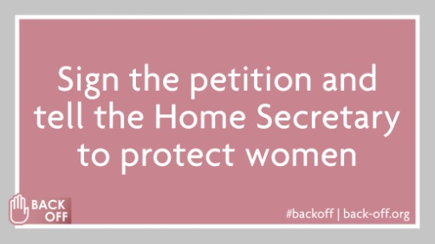The Issue UNISON is supporting British Pregnancy Advisory Service’s (BPAS) Back Off campaign which is supporting pregnancy choices and trusting women to decide. More and more women are having to face crowds of protestors outside abortion clinics.

The Hope The campaign aims to tell Sajid Javid to listen to women and continue with the Home Office review into abortion clinic harassment and obtain a buffer zone around abortion clinics.

The Action Please share the information, petitions across your members and in your networks

Further Info Rupa’s letter <https://www.buzzfeed.com/laurasilver/over-150-mps-have-told-sajid-javid-to-back-abortion-rights?utm_term=.em72KaZ5Z#.trGPZjKoK>.

Newsnight <https://www.bbc.co.uk/iplayer/episode/b0b2r9yn/newsnight-10052018>

The link is [www.back-off.org/sign-the-petition](http://www.back-off.org/sign-the-petition)

**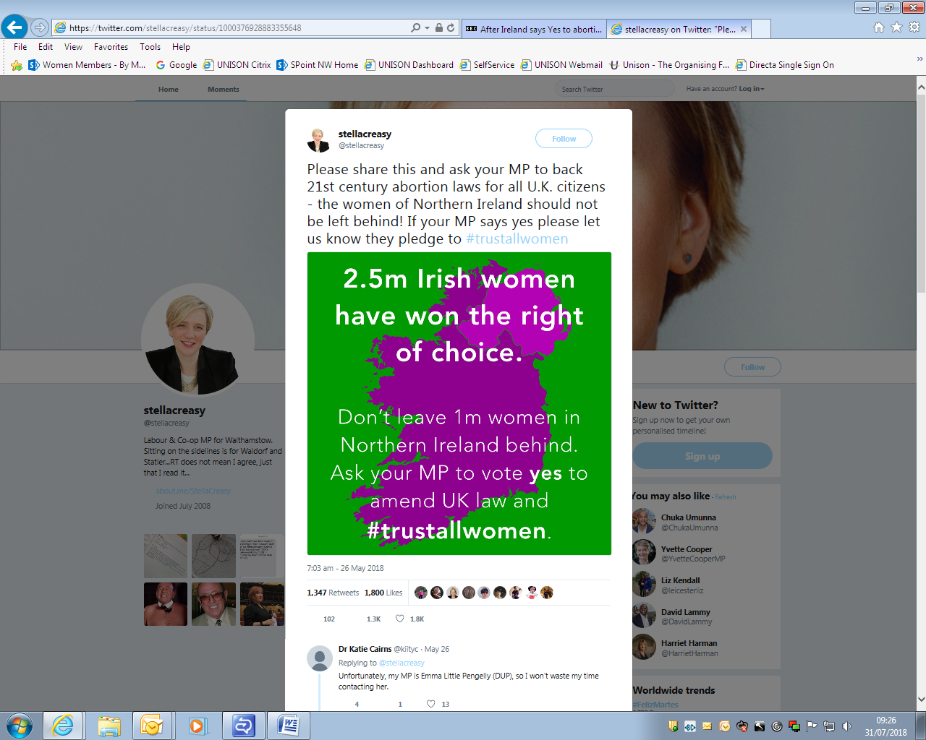**

**After Ireland says yes to abortion, what next for Northern Ireland?**

Update: The Republic of Ireland voted on in May 2018 to repeal part of its constitution that effectively outlawed abortion. That change will soon leave Northern Ireland as the only part of either the UK or Ireland where abortion is illegal unless there is a serious risk to a woman's life or health. Unlike other parts of the UK, the 1967 Abortion Act does not extend to Northern Ireland. [A Supreme Court judgment considering whether abortion law in Northern Ireland is incompatible with international human rights is expected later this year.](http://www.bbc.co.uk/news/uk-northern-ireland-41719365)

Read more: <https://www.bbc.co.uk/news/uk-northern-ireland-44271876>

**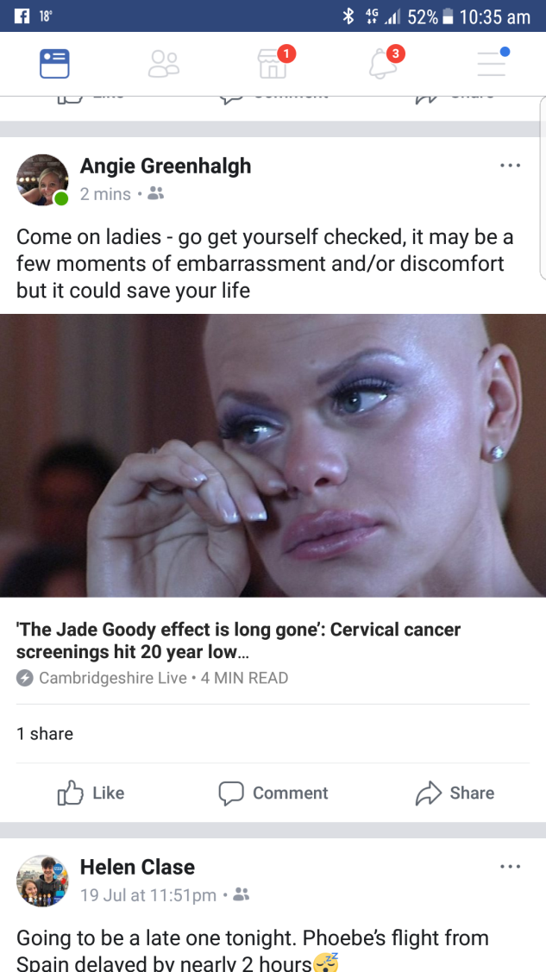Cervical Screening**

The Issue Cervical cancer screenings hit a 20 year low and campaigners say that the “Jade Goodey effect has long gone”

The Action Women are encouraged to get checked – a few moments of embarrassment and or discount could just save your life. Encourage all women to get checked whether they’re you, your mum, sister, friend or colleague.

Further Info Contact your local GP practice for more information.

**Period Poverty**

The Issue UNISON North West Women have been made aware of an extremely shocking statistic. Women across the UK are in period poverty as they struggle to afford basic sanitary products to give them dignity during their menstrual cycle. Food banks have said that more and more women are requesting sanitary items and that there is a general shortage of donations of these items. Girls and young women have also said that they do not feel able to ask already struggling parents to purchase products and as a result have resorted to using toilet paper, tissue or a sock.

The Hope We hope to make a real difference for these women so that no one has to live in Period Poverty.

The Action \*We are asking all Women’s Officers to set up a collection point in their workplaces where all staff can easily donate items. Local branches can develop local relationships with food banks, homeless shelters and women’s refuges.

\*Could your employer provide free sanitary products to staff and visitors to your workplace? <http://www.tampon.club/tampon-club-for-folks-who-dont-use-tampons/provide-free-tampons/>

Campaign Update \*Scotland becomes the first country in the world to provide free sanitary products to women on low incomes <https://www.independent.co.uk/news/uk/home-news/scotland-first-country-free-sanitary-products-tampon-tax-low-income-women-aberdeen-a7836441.html>

\*India has axed the Tampon Tax! Indian Finance Minister Piyush Goyal axed the country’s 12% tampon tax! Goyal says that period products are “now 100% exempt from tax” and that the government is happy to see the end of what was dubbed the “blood tax”. Period products will now be more affordable, while the period taboo has been slayed...

Further Info If you are looking to begin a collection make sure you have at least one recipient you can donate to. You can begin by following one of the links

Food Bank - <https://nameoffoodbank.foodbank.org.uk> <http://www.homeless.org.uk/homeless-england/search-near-me>.

Homeless & Refuges - <http://www.homeless.org.uk/homeless-england/search-near-me?distance%5Bpostal_code%5D=m34+6au&distance%5Bsearch_distance%5D=5&distance%5Bsearch_units%5D=mile&items_per_page=25&=Go>.

Boots the Chemists are also trailing collection points in stores you can read more by following this link <https://www.theguardian.com/society/2016/dec/16/boots-support-campaign-end-period-poverty-paula-sherriff-tampons>

****

**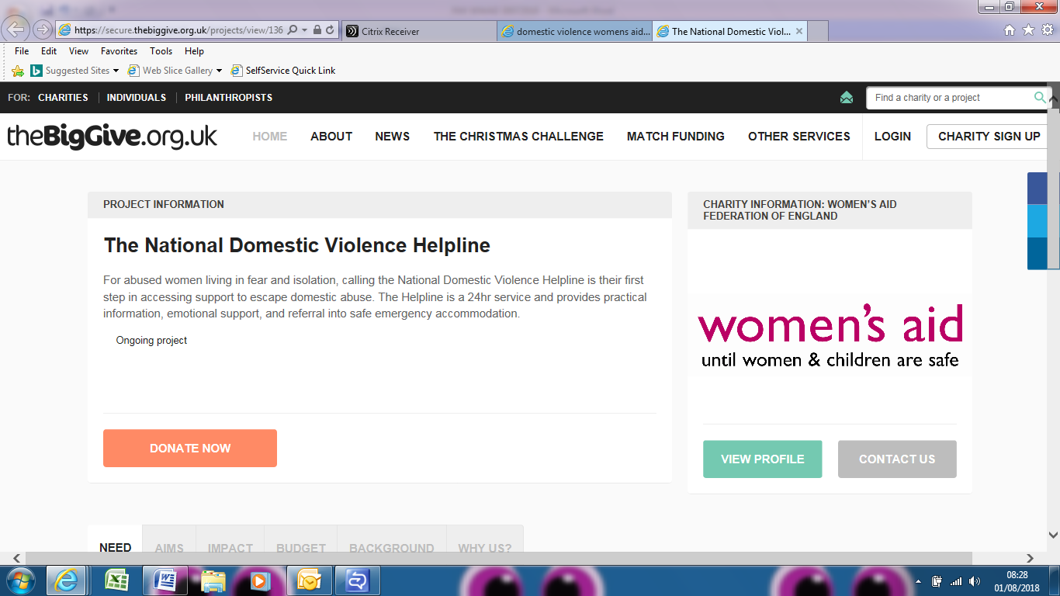Domestic Violence – Break the Silence**

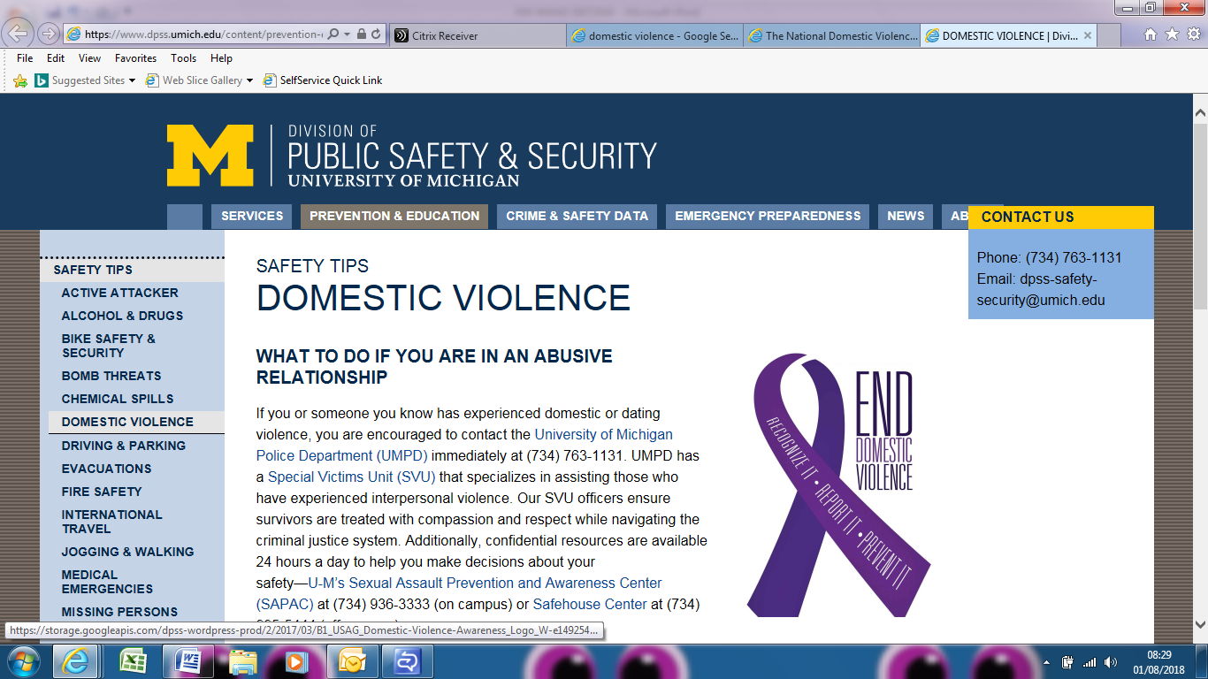The Issue Domestic Violence affects 1 in 4 women – physically, emotionally and financially. Domestic Violence is not just an issue at home but is a workplace issue as its effects are wide reaching causing women to be continually harassed in the workplace through phone calls, texts and emails or harassment where they work in a customer facing role. We are creatures of habit and we travel and park at the same time and the same place. Our minds are elsewhere and women take sick days to avoid having to think of a reason to explain that new bruise or why they have no money for their lunch. Women often are disciplined and dismissed as their work quality and quantity falls. UNISON North West has identified a number of employer domestic abuse policies which do not truly support those suffering at the hands of domestic abuse.  Whilst many employers lack any policy at all, UNISON has found policies that do not go far enough to support members.  Some policies do not have any reporting mechanisms where colleagues of the victim, who identify early signals of domestic abuse, can report concerns.  Other policies lay the burden of reaching out for help at the victims’ door.  So whilst those affected may be already finding it impossible to reach out to police and medical professionals an employer may well indicate in their policy that their expectation is that the employee should raise any abuse with them.

The Hope But it doesn’t have to be like that. Small and inexpensive adjustments to policies and ways of working can make a real difference to women. Changing work rotas or workplace location or giving time off with pay to deal with emergencies or housing. Not including periods of sickness absence that are DV related in sickness absence triggers.

The Action UNISON is encouraging all reps to work with employers to review and improve their policies to ensure that vital advice and support is given to staff.  It is so common for abuse to spill from the home into the workplace – which can also so often lead to members facing disciplinary action.  No one has the right to put someone in this position and we all have a duty to support anyone who is struggling with domestic abuse and to break the silence.

Further Info <https://www.unison.org.uk/content/uploads/2017/02/24192.pdf>

<https://www.cio.com/article/3106260/relationship-building-networking/domestic-violence-is-a-workplace-issue.html>

<https://www.theguardian.com/sustainable-business/domestic-violence-hidden-workplace-issue>

<http://www.growthbusiness.co.uk/domestic-violence-workplace-issue-2553085/>

**Agile Working** Women and young people are most likely to work on zero-hours contracts <https://www.peoplemanagement.co.uk/news/articles/women-young-people-on-zero-hours-contracts?utm_source=mc&utm_medium=email&utm_content=pm_daily_240418.4/24/2018.515928.Women+and+young+people+most+likely+to+work+on+zero-hours+contracts&utm_campaign=&utm_term>=

****

**The Pink Tax**

The Issue The pink tax is one that only about half of the population is subject to. And they probably aren’t even aware of it. Are you paying the pink tax?The pink tax refers to the extra amount women are charged for certain products or services. Things like dry cleaning, personal care products, and vehicle maintenance. So not only do women [make less](https://www.listenmoneymatters.com/the-gender-pay-gap/) but they pay more. Women also live longer so they actually **need** [more money](https://www.listenmoneymatters.com/passive-income-ideas/) for retirement. **It’s a load of crap.** There has been a lot of research on the pink tax that found that overall; women were paying more than men 42% of the time. **The results: Products for women or girls cost 7% more than comparable products for men and boys.**

* 7% more for toys and accessories - Unfortunately, the pink tax starts at birth. Across the six product categories of toys, the girls’ items were consistently more expensive than ones for boys. The largest price discrepancy was in helmets and knee/elbow pad. **The girls’ were priced a whopping 13% higher.** If you buy things for children, you probably already know of the price disparity. Pink bikes have a mark up on them. Items in a variety of colours were looked at and every time, **the pink-coloured item was the most expensive.** Pink items compared to other colours ranged from 2-15% more.
* 4% more for children’s clothing – women’s clothing can cost more than men’s clothes in six of seven clothes categories
* 8% more for adult clothing – when women are charged extra for plus sized clothing when men are not.
* 13% more for personal care products - These are the kinds of things you buy in a drug store, razors, shaving cream, deodorant, and face cleanser. So just buy men’s stuff! Unless you buy the fancy razors with multiple blades and “moisture strips,” the only difference between generic old stick razors for men and women is that ours are pink and theirs are blue. Surprisingly, colour has little effect on the hair removal process.
* 8% more for senior/home health care products
* Vehicle Repair – the old cliché is true. A [study](https://cdn.automd.com/reports/BusseIsraeliZettelmeyer_AutoRepair2013jun.pdf) revealed that men and women who called various repair shops asking about the cost of having a radiator replaced. Women who seemed clueless on the phone were quoted considerably more than men who acted in similarly uninformed way. Women, who bought used cars, were twice as likely to have been quoted a higher price than men.

The Action The best way to avoid this is to simply buy the men’s version of certain products and to do some homework and shop around for the best prices on things like dry cleaning. Or do what one women’s rights group in France have done. They started to uploaded photos of products that had unequal pricing. [Getting more confident](https://due.com/blog/how-women-in-business-can-become-more-confident/) and public shaming companies sometimes has a positive impact. Putting them on blast through something like Twitter will often garner faster results than writing letters and signing petitions.

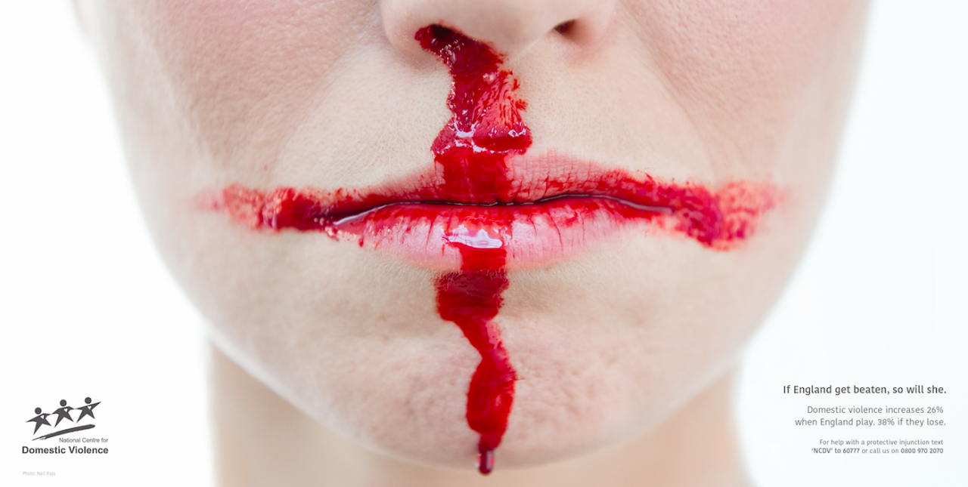

1 / 1

Reports of domestic violence increase 26% when England plays

Reports of domestic violence increase 26% when England plays

**Safety Pin Campaign**

The Issue UNISON North West Women note the rise in race and hate crime especially since the European Referendum decision. As a response the committee has decided to show of solidarity with members of our communities be they migrant workers, refugees or those with protected characteristics.

The Hope We hope to make a difference giving a clear message by encouraging all UNISON members to wear a safety pin so that if anyone at any time is in the community or using public transport they can easily identify a safe person from the safety pin they wear. No matter how we voted we must not allow a minority to discriminate and make anyone feel threatened.

The Action UNISON North West Women’s Committee have produced cards and pins free of charge to any member. If you would like to distribute pins in your branch and or workplace or if you are at any UNISON events where you would like to distribute pins please contact the committee by emailing [northwest.women@unison.co.uk](mailto:northwest.women@unison.co.uk).

Further Info If you want to know how the safety pin campaign started please follow this link <http://www.telegraph.co.uk/good-news/2016/06/29/safety-pins-used-to-fight-racism-and-show-solidarity-with-immigr/>

****

**Gender Pay Gap reporting: Too small a step in the right direction**

New [Gender Pay Gap Reporting](http://ier.us12.list-manage.com/track/click?u=f121e48a8bb6d3101590c12d3&id=2d5287a710&e=71131c031b) regulations came in, requiring employers of 250 or more workers to report on inequalities of pay between women and men by 2018. While this move towards greater transparency is a welcome step in the right direction, the legislation is let down by the glaring omissions of any form of sanction against employers who break the law, and the non-requirement for employers to take action on the gender pay gap beyond reporting on it. The Institute of Employment Rights argues that stronger trade union rights and the promotion of a union presence at both sectoral and enterprise levels across the economy is key to eliminating the pay gap, as well as other forms of inequality. As the [TUC points out](http://ier.us12.list-manage1.com/track/click?u=f121e48a8bb6d3101590c12d3&id=8cee87fb2b&e=71131c031b), sectoral collective bargaining - a key proposal within the IER's [Manifesto for Labour Law](http://ier.us12.list-manage.com/track/click?u=f121e48a8bb6d3101590c12d3&id=9c3c76bc4a&e=71131c031b) - could be a major factor in the closing of the pay gap, as it can be used to raise poor wages in female-dominated sectors such as care work.

**Swan Women’s Centre**

Local branches may wish to advertise the SWAN Women’s Centre in their communications with members. The centre is based in Sefton and supports women to achieve mental well-being and provides services for women who experience anxiety, depression, stress or mental health issues. Established in July 1989, SWAN was an organisation that provided information and advice to women on health issues. Since then, we have grown in line with the needs of the women that we serve locally. We now provide a range of services that promote mental well-being such as Mindfulness, Yoga and Complementary Therapies such as Reflexology, Thai Yoga, Reiki, Tui Na, Body Massage, Indian Head Massage, Hopi Candles etc.

The Centre also has a Therapeutic Allotment that women can get involved in, support each other, and build friendships as well as their confidence. For women who are affected by or experience anxiety, depression, stress, isolation or other mental health problems we provide a range of services such as a free Counselling Service, Outreach Service, Anxiety/Depression Support Groups, as well as Craft and Activity groups.

The current squeeze on public spending is challenging, but by working together with partners and commissioners, SWAN has continued to fulfil its pledge to provide local, innovative, and responsive services to women in Sefton. The centre is well located and has rooms which local branches may wish to consider using for courses and training. Branches may wish to consider making contact with the centre and offering financial or other support <http://www.swanwomenscentre.org/>

**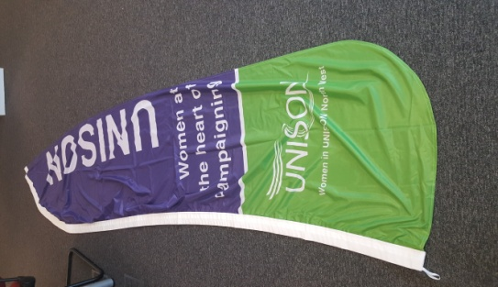Feather Event Banner**

UNISON North West Women now have a banner which can be easily carried on marches and rallies as it is very lightweight. It also can be stood in a heavy duty water stand at inside and outside events. For more information contact Sarah France [sarah.france@unison.co.uk](mailto:sarah.france@unison.co.uk) to book its use.

**Care work – a gendered issue**

Underpaid, undervalued and forced out of the labour market to care for relatives. Why care work is a gendered issue.<https://t.co/fAyttxHc77>

**Female Genital Mutilation – Let’s Talk App**

There is now an updated iPad version of Let’s talk FGM app available to install from the App Store. If you already have it on your iPad, please go to the App store and reinstall. This work was enabled by a generous contribution of £20,000 from the Oxford Health Charity following the original project which was developed from a Mary Seacole Leadership Award in 2015-16 funded by Health Education England supported by Unite the Union, The Royal College of Nursing, The Royal College of Midwives and UNISON. This version has the same content as the web-based app but as in the previous I-pad app it can be used off-line.

Remember you can also go to [Let’s talk FGM](http://letstalkfgm.nhs.uk)  for the web-app and save to your favourites. For further information or comments, please reply to [letstalkfgm@oxfordhealth.nhs.uk](mailto:letstalkfgm@oxfordhealth.nhs.uk)

Update - <https://www.femalista.com/history-have-been-made-female-genital-mutilation-banned-in-nigeria/>

**[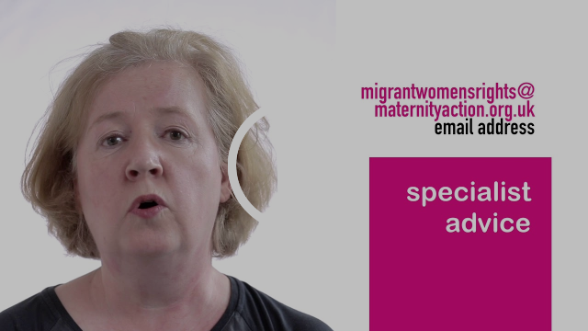](https://maternityaction.us1.list-manage.com/track/click?u=da51223b5e05b9dbb08034af8&id=21472638c4&e=b1baad5e6d)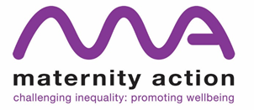Maternity rights and benefits**  
You might want to check out our info sheets on employment rights and benefits, including introductory information sheets on [maternity rights](https://maternityaction.us1.list-manage.com/track/click?u=da51223b5e05b9dbb08034af8&id=16aeeb69b9&e=b1baad5e6d) and [maternity benefits](https://maternityaction.us1.list-manage.com/track/click?u=da51223b5e05b9dbb08034af8&id=f84c934f32&e=b1baad5e6d), and information sheets on specific areas such as [redundancy](https://maternityaction.us1.list-manage.com/track/click?u=da51223b5e05b9dbb08034af8&id=04f9690fe9&e=b1baad5e6d), [health and safety](https://maternityaction.us1.list-manage.com/track/click?u=da51223b5e05b9dbb08034af8&id=655c82ba89&e=b1baad5e6d), [discrimination](https://maternityaction.us1.list-manage.com/track/click?u=da51223b5e05b9dbb08034af8&id=6b6878d6ca&e=b1baad5e6d), [breastfeeding](https://maternityaction.us1.list-manage.com/track/click?u=da51223b5e05b9dbb08034af8&id=343bbd48e3&e=b1baad5e6d) and [resigning during pregnancy](https://maternityaction.us1.list-manage.com/track/click?u=da51223b5e05b9dbb08034af8&id=89317852dd&e=b1baad5e6d) and maternity leave. Our [newest information sheet is on childbirth injuries](https://maternityaction.us1.list-manage.com/track/click?u=da51223b5e05b9dbb08034af8&id=83c7893e61&e=b1baad5e6d): rights at work and benefits.  We have short, informative videos designed to explain employment rights and benefits in a clear, accessible way. These videos discuss what [rights pregnant women have in the workplace](https://maternityaction.us1.list-manage.com/track/click?u=da51223b5e05b9dbb08034af8&id=96533b88f9&e=b1baad5e6d), [what steps to take when facing problems at work due to pregnancy](https://maternityaction.us1.list-manage.com/track/click?u=da51223b5e05b9dbb08034af8&id=1c7efd4dab&e=b1baad5e6d), and [tips on how and when to inform employers](https://maternityaction.us1.list-manage.com/track/click?u=da51223b5e05b9dbb08034af8&id=8986df07f5&e=b1baad5e6d) about pregnancy.

**Refugee, asylum seeker and migrant women's rights** – there are plenty of resources for those supporting vulnerable migrant women.  Find out about our [Migrant Women’s Rights Service](https://maternityaction.us1.list-manage.com/track/click?u=da51223b5e05b9dbb08034af8&id=d1ec90dfa8&e=b1baad5e6d), a free, second-tier advice service for midwives, voluntary sector and community workers who support migrant women. We give advice on the housing and support options for all migrants, refugees and asylum seekers, including women who have overstayed their visas.    
  
The website has detailed information on the rights and entitlements of [women with different forms of immigration status](https://maternityaction.us1.list-manage.com/track/click?u=da51223b5e05b9dbb08034af8&id=ae97cf584c&e=b1baad5e6d).  We have a new series of information sheets on financial support and housing for women from abroad, including women who are [refugees,](https://maternityaction.us1.list-manage.com/track/click?u=da51223b5e05b9dbb08034af8&id=871941d0bb&e=b1baad5e6d) [asylum seekers,](https://maternityaction.us1.list-manage.com/track/click?u=da51223b5e05b9dbb08034af8&id=a3e71a25f9&e=b1baad5e6d) [refused asylum seekers](https://maternityaction.us1.list-manage.com/track/click?u=da51223b5e05b9dbb08034af8&id=8054bb5b93&e=b1baad5e6d), and have [no recourse to public funds.](https://maternityaction.us1.list-manage.com/track/click?u=da51223b5e05b9dbb08034af8&id=d2a2078225&e=b1baad5e6d) Our newest one is on entitlement to [free prescriptions and other healthcare costs for pregnant women and low income families](https://maternityaction.us1.list-manage.com/track/click?u=da51223b5e05b9dbb08034af8&id=38b0ec1200&e=b1baad5e6d), including those who have no recourse to public funds.  
  
Particularly useful for women affected by up-front charging is our new information sheet on [refusals and delays in treatme](https://maternityaction.us1.list-manage.com/track/click?u=da51223b5e05b9dbb08034af8&id=20446474fa&e=b1baad5e6d)[nt](https://maternityaction.us1.list-manage.com/track/click?u=da51223b5e05b9dbb08034af8&id=b72a6bc519&e=b1baad5e6d) and on [charging for NHS maternity care](https://maternityaction.us1.list-manage.com/track/click?u=da51223b5e05b9dbb08034af8&id=8a208aa308&e=b1baad5e6d) more generally.  
  
We also have six video podcasts to help midwives and voluntary sector workers identify the different groups of migrants living in the UK and the issues they face. The [first video in the series](https://maternityaction.us1.list-manage.com/track/click?u=da51223b5e05b9dbb08034af8&id=b1e5335c1f&e=b1baad5e6d) is about our work with migrant women and training we can provide to support workers. We have videos devoted to rights and entitlements for the following: [EEA nationals](https://maternityaction.us1.list-manage.com/track/click?u=da51223b5e05b9dbb08034af8&id=b74af17194&e=b1baad5e6d), [women on short-stay visas](https://maternityaction.us1.list-manage.com/track/click?u=da51223b5e05b9dbb08034af8&id=36ba766f0d&e=b1baad5e6d), [asylum seekers](https://maternityaction.us1.list-manage.com/track/click?u=da51223b5e05b9dbb08034af8&id=e93c0431cf&e=b1baad5e6d), [victims of trafficking](https://maternityaction.us1.list-manage.com/track/click?u=da51223b5e05b9dbb08034af8&id=be858de874&e=b1baad5e6d) and [undocumented migrants](https://maternityaction.us1.list-manage.com/track/click?u=da51223b5e05b9dbb08034af8&id=5d3716592f&e=b1baad5e6d).

[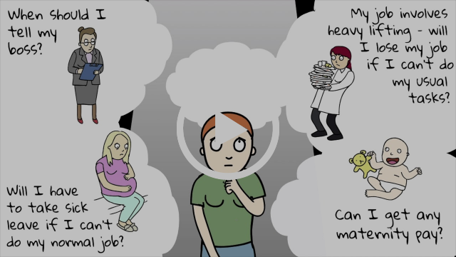](https://maternityaction.us1.list-manage.com/track/click?u=da51223b5e05b9dbb08034af8&id=216996159e&e=b1baad5e6d)When should I tell my employers I'm pregnant? Am I entitled to maternity pay? These and other questions answered in this short video.

The Migrant Women’s Rights Service on 020 7251 6189 helpline is open Monday and Thursday between  2-4pm.   
For email advice: [migrantwomensrights@maternityaction.org.uk](mailto:migrantwomensrights@maternityaction.org.uk) (we aim to reply to all email requests within three working days).

For free advice on charging and access to NHS maternity care: Freephone: 0808 800 0041 Thursdays from 10 am to 12 am.   
Email enquiries: [maternitycareaccess@maternityaction.org.uk](mailto:maternitycareaccess@maternityaction.org.uk) Keep receiving our updates - [**Click here to let us know that you want to keep on hearing from us.**](mailto:info@maternityaction.org.uk?subject=Confirm%20my%20subscription&body=I%20confirm%20that%20I%20would%20like%20to%20continue%20receiving%20e-mail%20updates%20from%20Maternity%20Action.)

**unison.org.uk/ bargaining**

In-depth guides and model agreements for effective negotiating and bargaining including:

* [Branch guide to gender pay reporting](https://www.unison.org.uk/content/uploads/2017/04/GENDER_PAY_REPORTING_April_2017-1.pdf)
* [Medical screening leave factsheet](https://www.unison.org.uk/content/uploads/2017/05/Medicalscreeningleave.pdf)
* [Menopause factsheet](https://www.unison.org.uk/content/uploads/2017/05/Menopause-and-Work.pdf)
* [Negotiating for working parents](https://www.unison.org.uk/content/uploads/2017/03/Working-parents.pdf)
* [Women’s reproductive health issues](https://www.unison.org.uk/content/uploads/2017/05/Womens-reproductive-health-issues.pdf)

unison.org.uk/onlinecatalogue

The way for branches to make bulk orders of UNISON stock items including:

* [Organising for equality: UNISON guidelines on self-organisation](https://www.unison.org.uk/content/uploads/2014/05/On-line-Catalogue222252.pdf), stock number 1577
* [A guide to equality in UNISON](https://www.unison.org.uk/content/uploads/2013/06/On-line-Catalogue205373.pdf), stock number 2778
* [Flexible working: making it work](https://www.unison.org.uk/content/uploads/2014/09/On-line-Catalogue225422.pdf), stock number 0303
* [Harassment at work – a UNISON guide](https://www.unison.org.uk/content/uploads/2016/12/24159.pdf), stock number 1359
* [Domestic violence and abuse: a trade union issue](https://www.unison.org.uk/content/uploads/2017/02/24192.pdf), stock number 3477
* [We won’t look the other way: domestic abuse poster](https://www.unison.org.uk/content/uploads/2015/09/23360.pdf), stock number 2539
* [We won’t look the other way: domestic abuse leaflet](https://www.unison.org.uk/content/uploads/2015/08/23364.pdf), stock number 3558
* [Menopause and work](https://www.unison.org.uk/content/uploads/2017/06/20472.pdf), stock number 3075
* [Gender, safety and health](https://www.unison.org.uk/content/uploads/2016/07/23965.pdf), stock number 1982
* [Women and Pensions: what can you do to get a decent income in retirement](https://www.unison.org.uk/content/uploads/2017/02/24231.pdf) stock number 3723
* [Counting the cost: how council cuts shrink women’s lives (from 2014](https://www.unison.org.uk/content/uploads/2014/06/On-line-Catalogue224222.pdf)), stock 3414

UNISON’s analysis of responses from councils across the UK and women surveyed about their experiences of cuts.

**S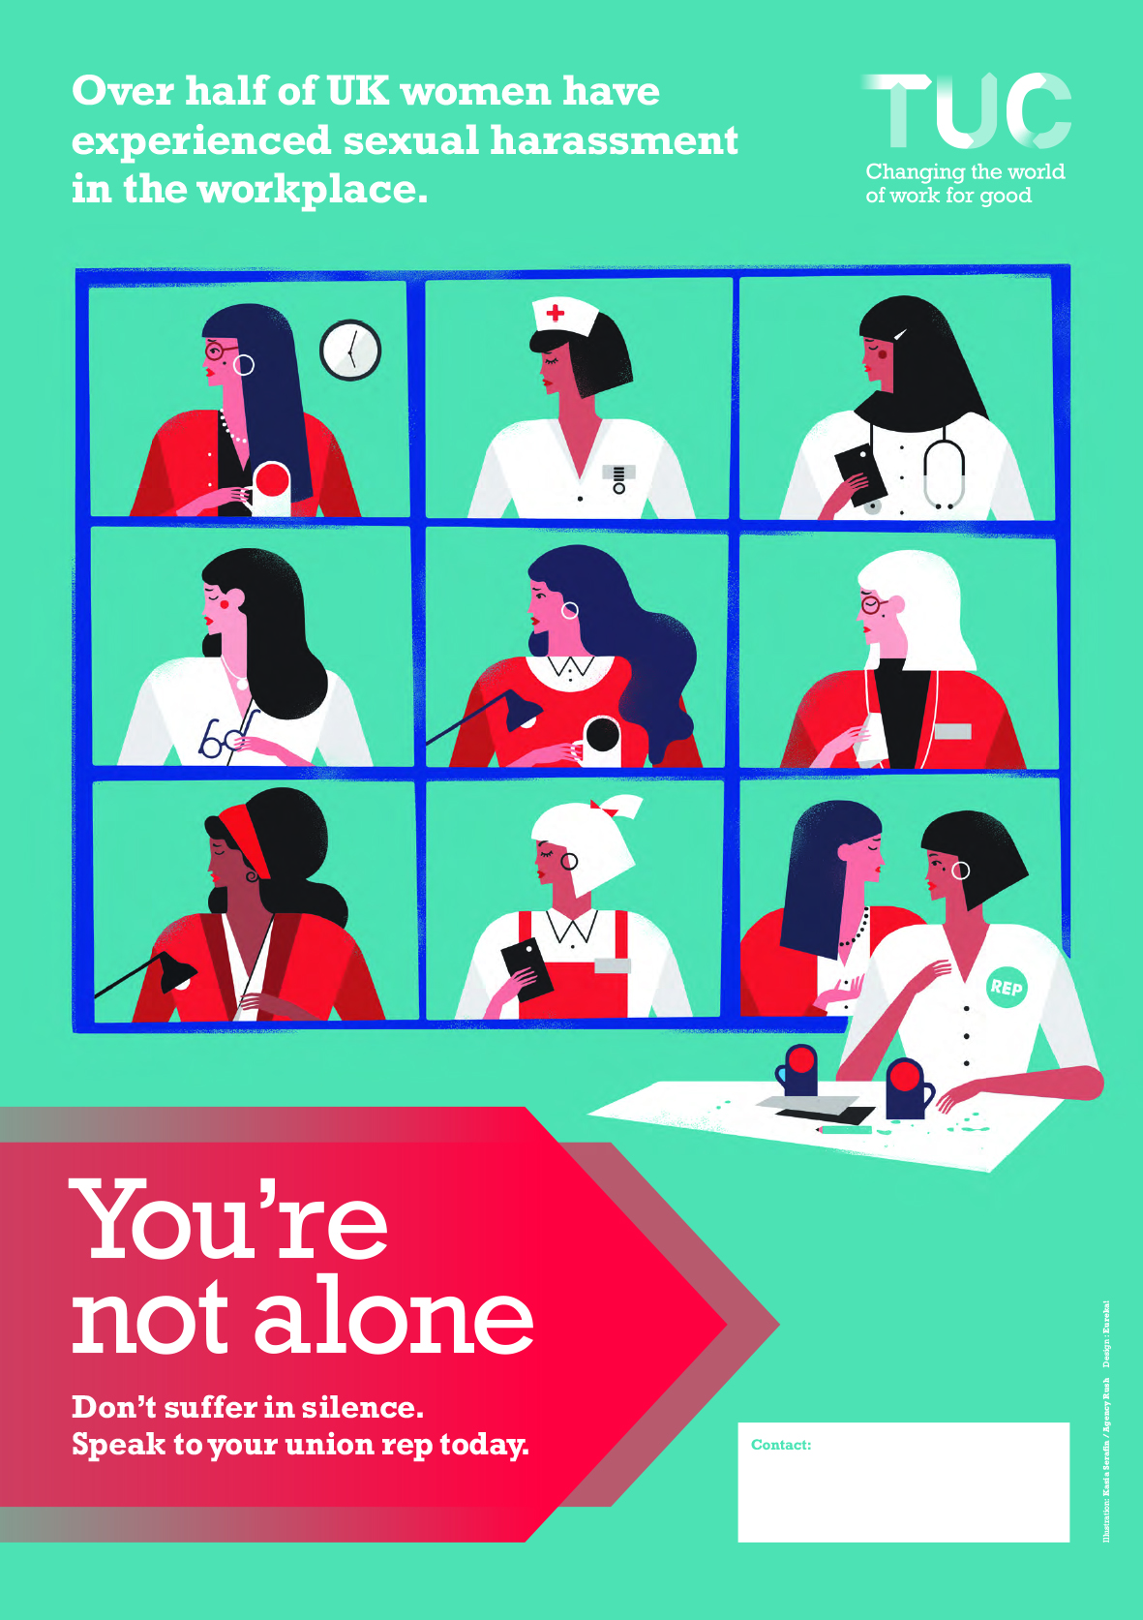exual harassment**

As you may know the TUC published a report last year [*Still Just a Bit of Banter?*](https://www.tuc.org.uk/sites/default/files/SexualHarassmentreport2016.pdf) looking at the experiences of women in the workplace who experience sexual harassment, with recommendations to unions and employers. The report has been well received and the TUC have [an e-learning note](https://www.tuc.org.uk/bite-sized-learning) for reps.

The TUC have also produced a poster for workplaces highlighting the issue of sexual harassment and encouraging people to report it to their union rep. To order email to [publications@tuc.org.uk](mailto:publications@tuc.org.uk) quoting sock code ER288. There is a small charge for posters. P&P is free.

Update: Employers warned over use of NDAs in sexual harassment cases <https://www.peoplemanagement.co.uk/news/articles/employers-warned-ndas-sexual-harassment?utm_source=mc&utm_medium=email&utm_content=pm_daily_270418.4/27/2018.518841.Employers+warned+over+use+of+NDAs+in+sexual+harassment+cases&utm_campaign=&utm_term>=

# Getting the Balance Right

A new tool kit, which sets out the rules, gives advice and guidance on how to meet the commitment, engage more women, set up a branch women’s group, and much more.  You can download an electronic copy using this link <https://www.unison.org.uk/content/uploads/2017/02/24224.pdf> , hard copies can also be ordered from online publications [www.unison.org.uk/onlinecatalogue](http://www.unison.org.uk/onlinecatalogue) using stock number 3714.

**Women & Pensions**

|  |
| --- |
| A new Women and Pensions briefing can be downloaded from the UNISON website at <https://www.unison.org.uk/content/uploads/2017/02/24231.pdf> or ordered directly from the UNISON Online Publications, [www.unison.org.uk/onlinecatalogue](http://www.unison.org.uk/onlinecatalogue), Stock Order Number 3723. **WASPI fight for pension justice continues** |
| UNISON continues its active support of the [**WASPI (Women Against State Pension Inequality)**](http://msg.unison.org.uk/c/14djxXw7m6CYxyBKPIp) campaign with national delegate conference voting in favour of the motion on the issue, and with many delegates speaking out about the injustice.  **Our union has always championed fair pensions.** This campaign highlights how women born on or after 6 April 1950 have been unfairly penalised by the equalisation of the state pension age with no fair transitional arrangements. [Get your branch campaigning: WASPI](http://msg.unison.org.uk/c/14djGHaUJ0ZqfejM98k) |

Website for campaign details and action, and to contact them about local groups - [www.waspi.co.uk](http://www.waspi.co.uk) Twitter @WASPI\_Campaign Facebook <https://www.facebook.com/WASPI-Women-Against-State-Pension-Inequality-Campaign-877054125688402/>  
UNISON leaflets Women and Pensions briefing <https://www.unison.org.uk/content/uploads/2017/02/24231.pdf>   
WASPI campaign <https://www.unison.org.uk/content/uploads/2017/01/24214.pdf>

|  |
| --- |
| Women Deserve Better (survey results of women aged over 50 in the workplace) <https://www.unison.org.uk/content/uploads/2014/03/Policieswomen-deserve-better-v2b2.>[pdf](https://www.unison.org.uk/content/uploads/2014/03/Policieswomen-deserve-better-v2b2.pdf) UNISON's briefing on the Children and Social Work Bill <https://www.unison.org.uk/24068/>  End Violence Against Women Coalition report 'All day, every day' looking at sexual harassment in schools <http://www.endviolenceagainstwomen.org.uk/schools-safe-4-girls> A BBC news item explaining the situation about s-x and relationships education in schools. <http://www.bbc.co.uk/news/education-39116783>  **Anti-Slavery International**  [antislavery.org](http://www.antislavery.org/) UNISON Centre international team supports/affiliates to this organisation and encourages branches and regions to similarly support  **Women and safer public transport** |
| [Get your branch campaigning: Better Transport](http://msg.unison.org.uk/c/14dm5dms0t91dFo8teX) Nearly 85% of respondents to our recent survey use public transport, buses in particular. But, whilst most of us felt safe during the day, travel after 9pm was when women felt most vulnerable.  As one woman stressed: **“If public transport was cheaper, more frequent and properly staffed I think everyone would use it more, not just women.”**  Thanks to all who completed the survey. |
|  |

**Securing Equality**

A guide to Public Sector Equality Duty to fight local cuts. Stock order 3814.

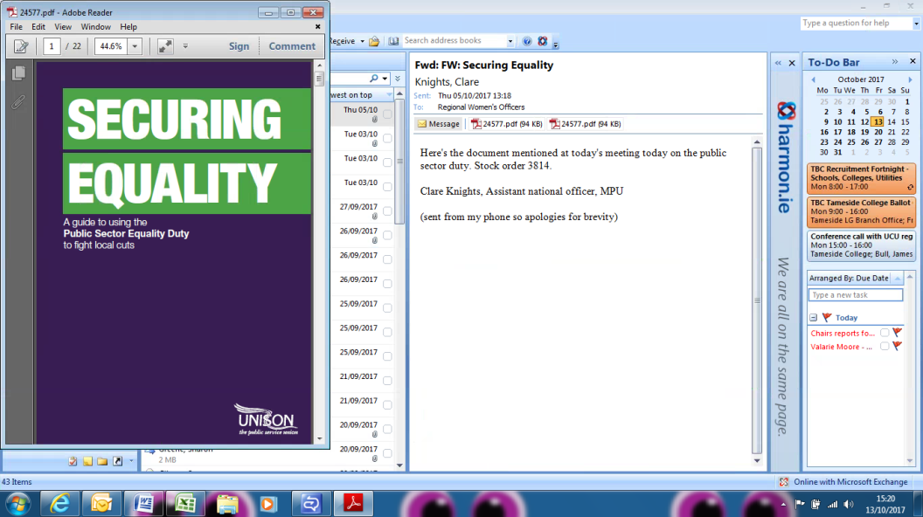 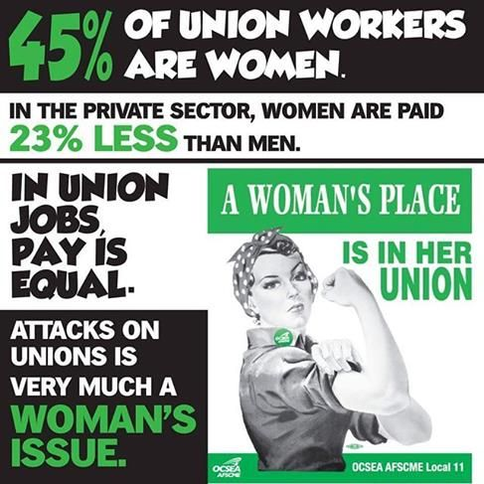

\_\_\_\_\_\_\_\_\_\_\_\_\_\_\_\_\_\_\_\_\_\_\_\_\_\_\_\_\_\_\_\_\_\_\_\_\_\_\_\_\_\_\_\_\_\_\_\_\_\_\_\_\_\_\_\_\_\_\_\_\_\_\_\_\_\_\_\_\_\_\_\_\_\_\_\_\_\_\_\_\_\_\_\_\_\_\_\_\_\_\_\_\_\_\_\_\_\_

**UNISON North West Women’s Committee**

UNISON North West I Arena Point I 1 Hunts Bank I Manchester I M3 1UN

0161 661 6797 I 0800 0 857 857

Email:[northwest.women@unison.co.uk](mailto:northwest.women@unison.co.uk) I Facebook: [www.facebook.com/unisonwomen](http://www.facebook.com/unisonwomen)

Twitter: [@WomenInUNISON](http://www.twitter.com/WomenInUNISON) I Website: [www.unison.org.uk/women](http://www.unison.org.uk/women)