Dear Branch Secretary,

1819-2019 Peterloo Massacre
Bi-Centenary March for Democracy
Join the March - Sunday 18th August 2019
RALLY IN ALBERT SQUARE - STARTS @ 1.00pm

Confirmed speakers at this time

Matt Wrack (General Secretary, Fire Brigades Union)
Julie Ward MEP (North West Labour MEP)
Ian Hodson (President, Bakers, Food & Allied Workers' Union)
Lynn Collins (Regional Secretary, North West TUC)
Owen Winter (Director, Make Votes Matter)
Marlene Walker (NHS Worker & Campaigner)
Pete Middleman (NW National Education Union)
Gina Dowding (North West Green Party MEP)
Ian Allinson (President, Manchester Trades Council)
Felicity Dowling (National Secretary, Left Unity)
Mark Krantz (Peterloo Historian & Political Activist)
Paula Barker (Regional Convenor, UNISON North West)

Alan Davies (The Word Newspaper & Peterloo March for Democracy Organising Committee)

Presiding: Stephen Hall (President, GMATUC)

Speakers will be grouped into threes and limited to 7 minutes each. Each group of three will be 'interspersed' with entertainment provided by Joe Solo, Claire Mooney, Bard Company and Crispin Flintoff. There will also be entertainment at the end of the speakers.

UNISON NORTH WEST IS URGING MEMBERS TO JOIN THIS MARCH!

UNISON North West Regional Committee has agreed to support this march to commemorate the Peterloo Massacre on its two hundredth anniversary. We have been offered, and have agreed to provide support for, one of ten feeder legs of the march, all of which will make their way to and meet at Albert Square near the site of the massacre in 1819.

WHAT WAS THE PETERLOO MASSACRE

Two hundred years ago, on August 1819, about 60,000 people assembled, including a high proportion of women and children, in St Peters field in Manchester. What followed was a brutal dispersal, by armed cavalry, with fifteen people killed and over five hundred injured. People had marched from all around, many miles, to peacefully demonstrate, amidst widespread hunger and deprivation, for the right to vote. That working people, by securing a voice over their fate, might be heard and might share justly in the wealth they toiled to create in the workshop of the world.

WHY REMEMBER IT?

This is a truly shameful day in the history of the conservative political establishment in Britain. Yet in the history of the labour movement, this event, known as the Peterloo Massacre, has come to symbolise the centuries of unremitting political struggle that moved working people from abject poverty and squalor, and back breaking labour, to the rights we now enjoy today. It inspired the rise of the Chartists and modern trade unionism and helped transform our history. Yet these struggles are never over, they must be fought again and again. After a decade of pay stagnation, growing poverty and austerity, it is more important than ever that we use the rights that others had to fight and die for to improve the lot of all working people.

UNISON NORTH WEST – FEEDER LEG TWO

Each leg will receive a banner marked "1819-2019 Peterloo Massacre Bi-Centenary - March for Democracy" to go at the front of the marchers and 500 copies of a Souvenir Newspaper which we will give away to the marchers and the general public en route and at Albert Square. Bundles of the 10,000 copy limited edition paper are also available from GMATUC on a first come first served basis (contact Alan on 07958 158080).

We are looking for volunteers to steward this leg of the march, and we will provide all all the necessary information to ensure the safety of the marchers from start to finish, including for the duration of the rally in Albert Square.

ASSEMBLY POINT - HORNBY STREET OFF BURY ROAD NEW ROAD, MANCHESTER. .
We have been asked to primarily focus on mobilising on our own members in the North West and wider afield, but other people from the North Manchester, Prestwich and Bury area will be advised to join this assembly point. Anyone else of course, is free to join them.

WHAT YOU CAN DO!

Please circulate information about this march. Encourage activists and members to attend with families.

Please email nwmedia@unison.co.uk to let us know that you’re branch is planning to attend, roughly how many attendees you expect, and whether you will bring a branch banner.

ASSEMBLY POINT - HORNBY STREET OFF BURY ROAD NEW ROAD, MANCHESTER

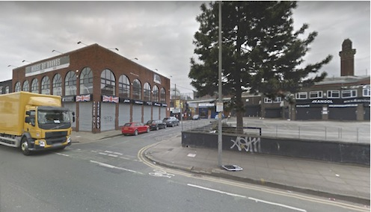

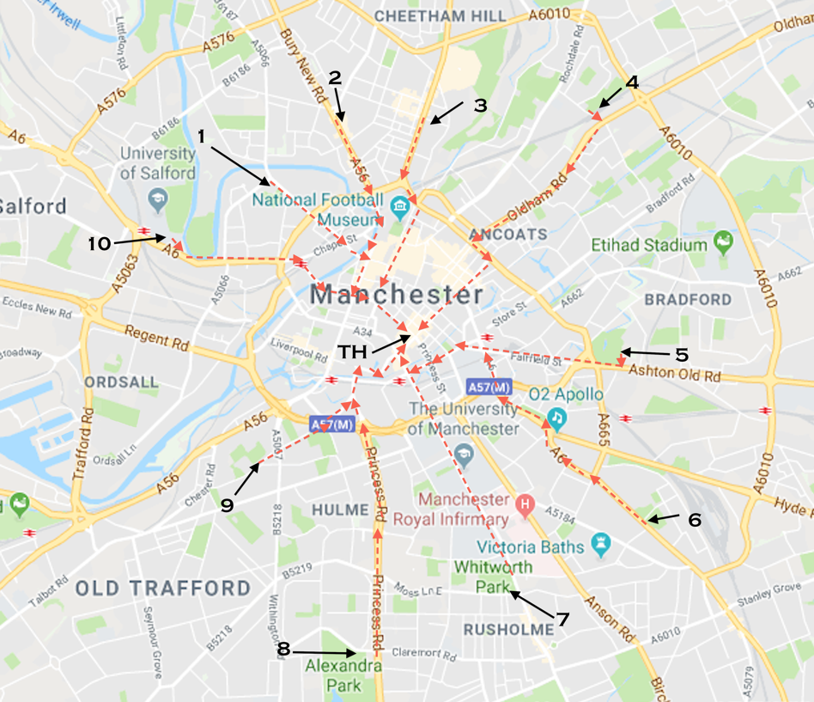

NB) The exact march routes have not yet been finalised with GMP. The above broken red lines, however, indicate something close to what is likely to be agreed.

