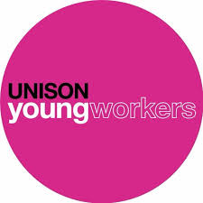
North West Region Young Members Political School 2020
The Young Members Political School is an annual event for UNISON young members in the North West. The event is open to Young Members Officers and also young members who want to develop their political understanding and want to get more involved with trade union activities.
This year’s political school features:

- Workshop run by the Ron Todd Foundation, an organisation that tackles the issues surrounding poverty and challenges social injustice
- Talk from Labour councillor Laura Smith
- Conversation with UNISON North West’s Black Members group
- Optional social activities on Saturday evening.

This year’s Young Members Political School is held in Liverpool. The weekend starts at 4.15pm on Friday and finishes at 1.45pm on Saturday. Meals are provided and if you aren’t from the Liverpool area, we can provide accommodation for you.
To book your place, please return the application form to Lyndsey Marchant l.marchant@unison.co.uk. You must be under 27 to attend the Political School.

